TRAINING INSTITUTE MANAGEMENT SYSTEM
Mini Project – Database Management System
B.Sc. Data Science
Semester III
SDBI
Submitted By,
Mandar Santosh Shinde
Roll No.: 20983
Academic Year: 2026–2027

Introduction

The Training Institute Management System is a database management project designed to manage the activities of a training institute in an organized manner. The system maintains information about students, trainers, courses, batches, enrollments, attendance and assessment results.
The database helps the institute store and retrieve information efficiently and reduces the problems associated with maintaining records manually. It also provides useful reports related to student enrollment, attendance, assessment performance and training progress.
MySQL/MariaDB is used to implement the database, while SQL queries are used to retrieve and analyse the stored information.

Objective
The main objective of the Training Institute Management System is to design and implement a relational database for managing the activities of a training institute.
The objectives of the project are:
- To maintain student information.
- To maintain trainer information.
- To store course details and fees.
- To manage batches and their schedules.
- To record student enrollments.
- To maintain student attendance records.
- To store assessment results.
- To generate useful reports using SQL queries.
- To analyse student performance and attendance.
- To provide a student-wise training progress report.

Database Design
The database is designed using a relational database model. The system contains seven main tables:
- Student
- Trainer
- Course
- Batch
- Enrollment
- Attendance
- AssessmentResult
A view named StudentProgress is also created to generate a student-wise training progress report.

Entity Relationship Diagram of Training Institute Management System:
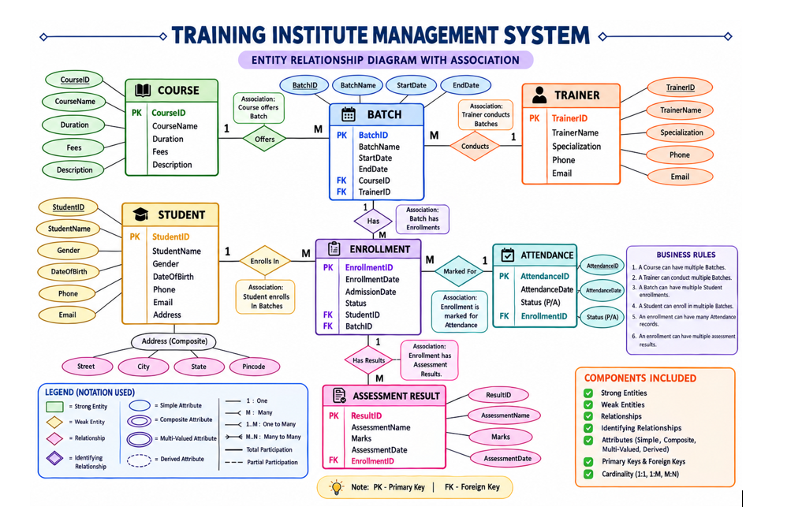

Database Schema Diagram
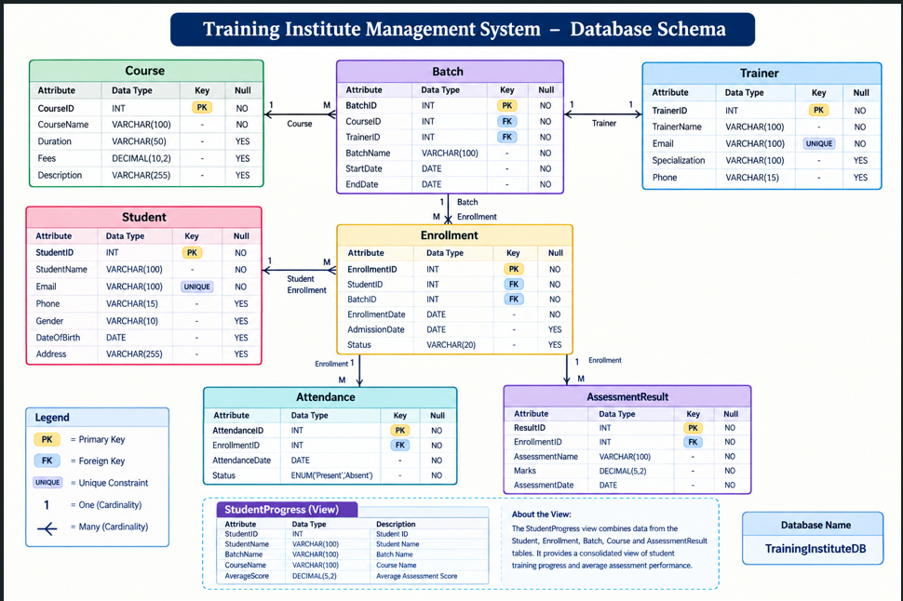

Student Table:
Field | Description
StudentID | Primary Key
StudentName | Name of student
Email | Student email
Phone | Contact number
Gender | Gender
DateOfBirth | Date of birth
Address | Student address

Trainer Table
Field | Description
TrainerID | Primary Key
TrainerName | Trainer name
Email | Trainer email
Specialization | Area of specialization
Phone | Contact number

Course Table

Field | Description
CourseID | Primary Key
CourseName | Name of course
Duration | Course duration
Fees | Course fees
Description | Course description

Batch Table

Field | Description
BatchID | Primary Key
CourseID | Foreign Key
TrainerID | Foreign Key
BatchName | Batch name
StartDate | Starting date
EndDate | Ending date

Enrollment Table

Field | Description
EnrollmentID | Primary Key
StudentID | Foreign Key
BatchID | Foreign Key
EnrollmentDate | Enrollment date
AdmissionDate | Admission date
Status | Enrollment status

Attendance Table

Field | Description
AttendanceID | Primary Key
EnrollmentID | Foreign Key
AttendanceDate | Attendance date
Status | Present/Absent

AssessmentResult Table

Field | Description
ResultID | Primary Key
EnrollmentID | Foreign Key
AssessmentName | Assessment name
Marks | Assessment marks
AssessmentDate | Assessment date

Relationships Between Tables:

Relationship | Type
Course → Batch | One-to-Many
Trainer → Batch | One-to-Many
Student → Enrollment | One-to-Many
Batch → Enrollment | One-to-Many
Enrollment → Attendance | One-to-Many
Enrollment → AssessmentResult | One-to-Many

Primary keys uniquely identify records in each table, while foreign keys establish relationships between related tables and maintain referential integrity.

Student Sample Data:
StudentID | StudentName | Gender | Email
1 | Rahul Sharma | Male | rahul@gmail.com
2 | Priya Patil | Female | priya@gmail.com
3 | Amit Joshi | Male | amit@gmail.com
4 | Sneha Kulkarni | Female | sneha@gmail.com
5 | Rohan Deshmukh | Male | rohan@gmail.com

The database contains 10 student records, 4 trainer records, 4 course records, 6 batch records, 15 enrollment records, 49 attendance records and 30 assessment result records.

Display Students with Their Batch and Course:
Purpose: Displays student enrollment details along with batch and course information.
QUERY
SELECT
b.BatchName,
s.StudentID,
s.StudentName,
c.CourseName
FROM Batch b
JOIN Enrollment e
ON b.BatchID = e.BatchID
JOIN Student s
ON e.StudentID = s.StudentID
JOIN Course c
ON b.CourseID = c.CourseID
ORDER BY b.BatchID, s.StudentID;

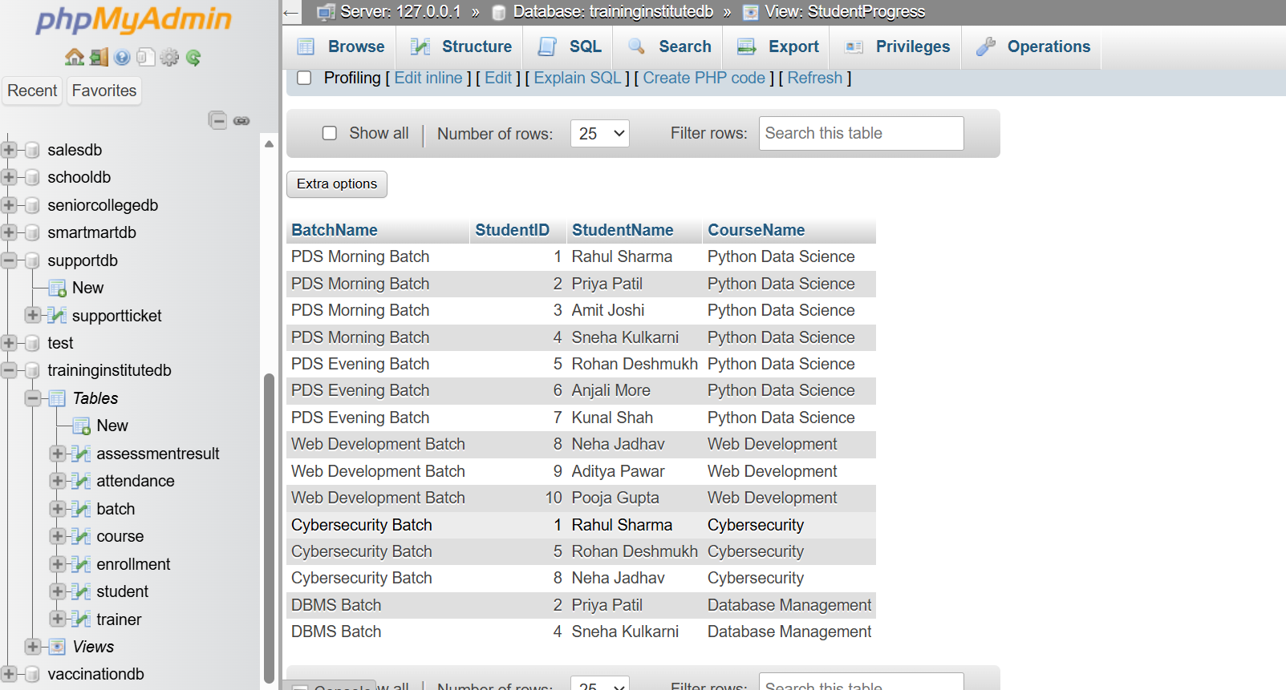

Display Batch, Course and Trainer Details
Purpose: Shows which trainer is assigned to each batch and the course being conducted.
QUERY

SELECT
b.BatchID,
b.BatchName,
c.CourseName,
t.TrainerName,
t.Specialization
FROM Batch b
JOIN Course c
ON b.CourseID = c.CourseID
JOIN Trainer t
ON b.TrainerID = t.TrainerID
ORDER BY b.BatchID;

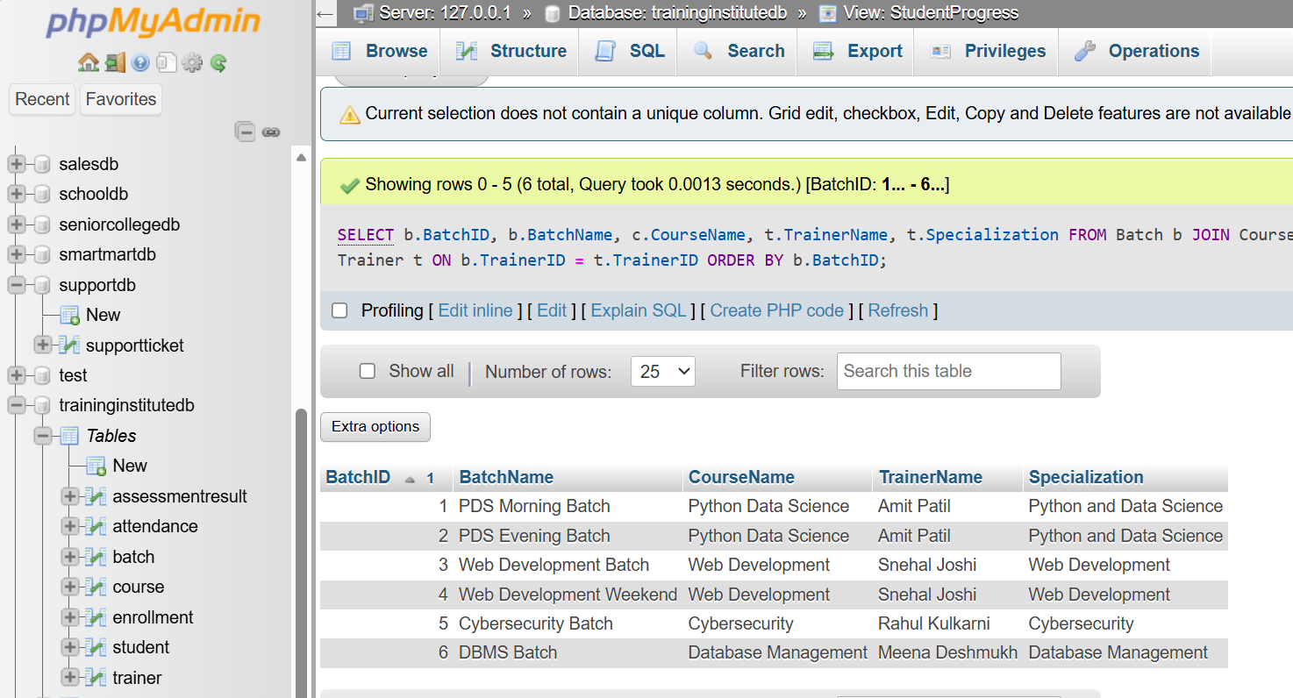

Total Students in Each Course
Purpose: Calculates the number of enrolled students for every course.
QUERY

SELECT
c.CourseID,
c.CourseName,
COUNT(e.StudentID) AS TotalStudents
FROM Course c
JOIN Batch b
ON c.CourseID = b.CourseID
JOIN Enrollment e
ON b.BatchID = e.BatchID
GROUP BY
c.CourseID,
c.CourseName
ORDER BY c.CourseID;
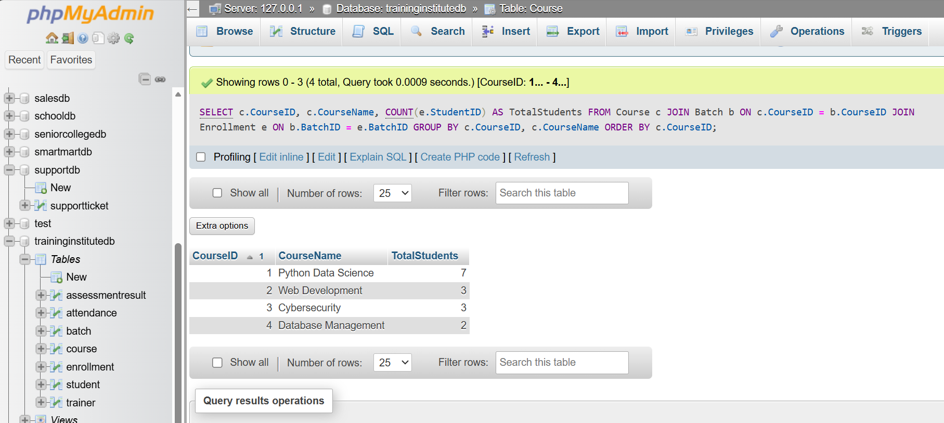

Batches Having More Than 2 Students
Purpose: Identifies batches with a relatively large number of enrolled students.
QUERY
SELECT
b.BatchID,
b.BatchName,
COUNT(e.StudentID) AS TotalStudents
FROM Batch b
JOIN Enrollment e
ON b.BatchID = e.BatchID
GROUP BY
b.BatchID,
b.BatchName
HAVING COUNT(e.StudentID) > 2
ORDER BY TotalStudents DESC;
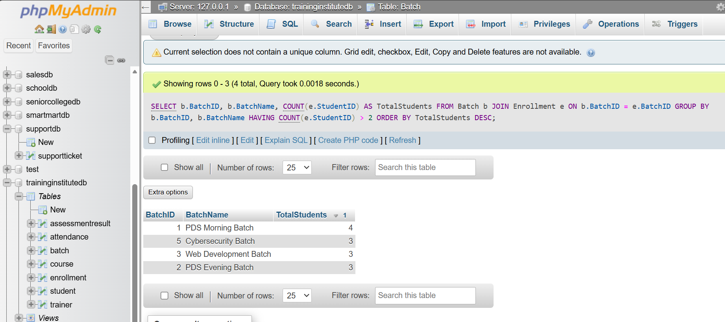

Student Attendance Percentage
Purpose: Calculates the attendance percentage of each student.
QUERY
SELECT
s.StudentID,
s.StudentName,
ROUND(
(
SUM(
CASE
WHEN a.Status = 'Present' THEN 1
ELSE 0
END
) * 100.0
) / COUNT(a.AttendanceID),
2
) AS AttendancePercentage
FROM Student s
JOIN Enrollment e
ON s.StudentID = e.StudentID
JOIN Attendance a
ON e.EnrollmentID = a.EnrollmentID
GROUP BY
s.StudentID,
s.StudentName
ORDER BY AttendancePercentage DESC;
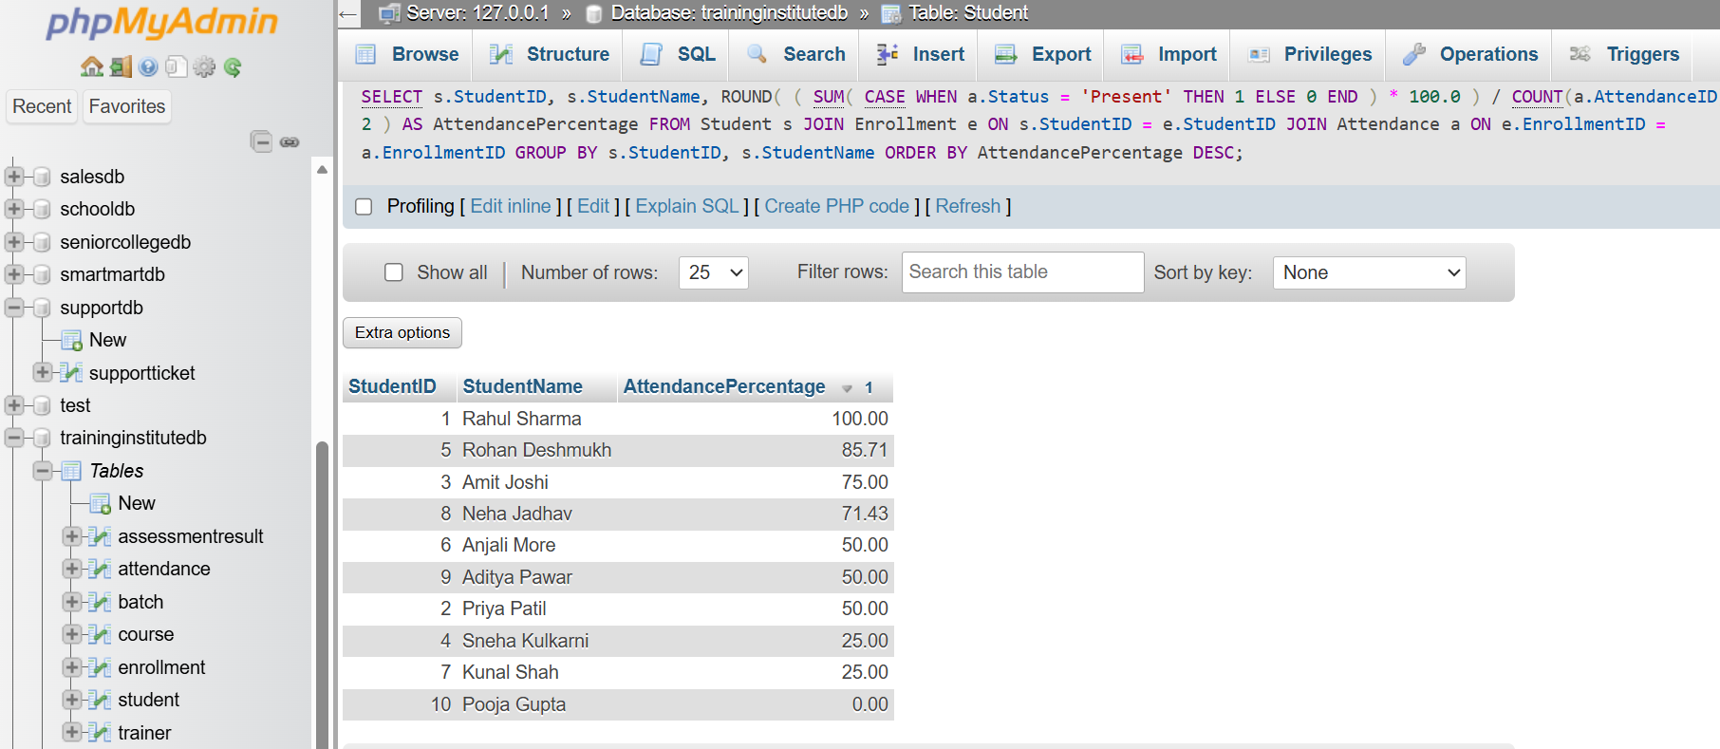

Average Assessment Score by Batch
QUERY
SELECT
b.BatchID,
b.BatchName,
ROUND(AVG(ar.Marks), 2) AS AverageScore
FROM Batch b
JOIN Enrollment e
ON b.BatchID = e.BatchID
JOIN AssessmentResult ar
ON e.EnrollmentID = ar.EnrollmentID
GROUP BY
b.BatchID,
b.BatchName
ORDER BY b.BatchID;
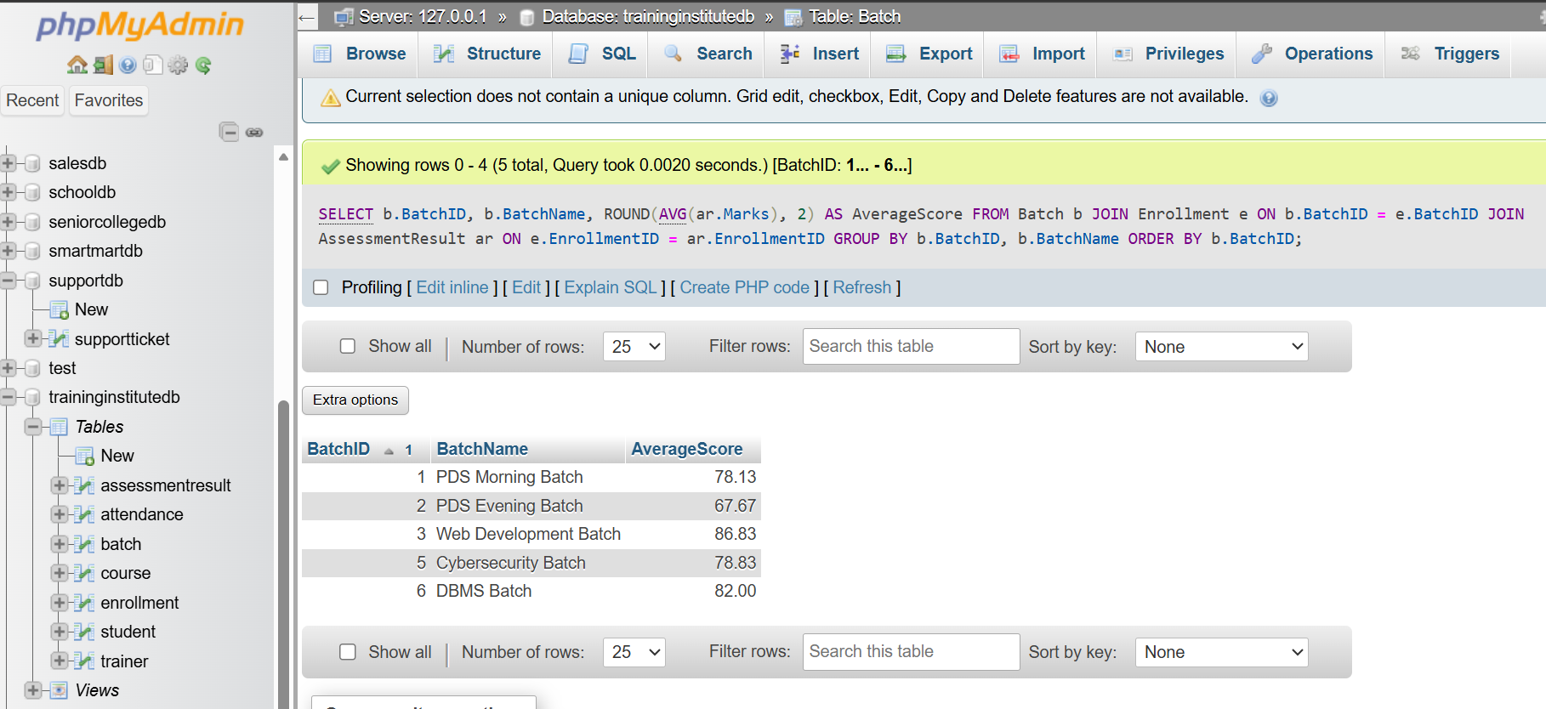

Highest Performing Student in Each Batch
QUERY
WITH StudentScores AS (
SELECT
b.BatchID,
b.BatchName,
s.StudentID,
s.StudentName,
ROUND(AVG(ar.Marks), 2) AS AverageScore,
RANK() OVER (
PARTITION BY b.BatchID
ORDER BY AVG(ar.Marks) DESC
) AS StudentRank
FROM Batch b
JOIN Enrollment e
ON b.BatchID = e.BatchID
JOIN Student s
ON e.StudentID = s.StudentID
JOIN AssessmentResult ar
ON e.EnrollmentID = ar.EnrollmentID
GROUP BY
b.BatchID,
b.BatchName,
s.StudentID,
s.StudentName
)
SELECT
BatchID,
BatchName,
StudentID,
StudentName,
AverageScore
FROM StudentScores
WHERE StudentRank = 1
ORDER BY BatchID;

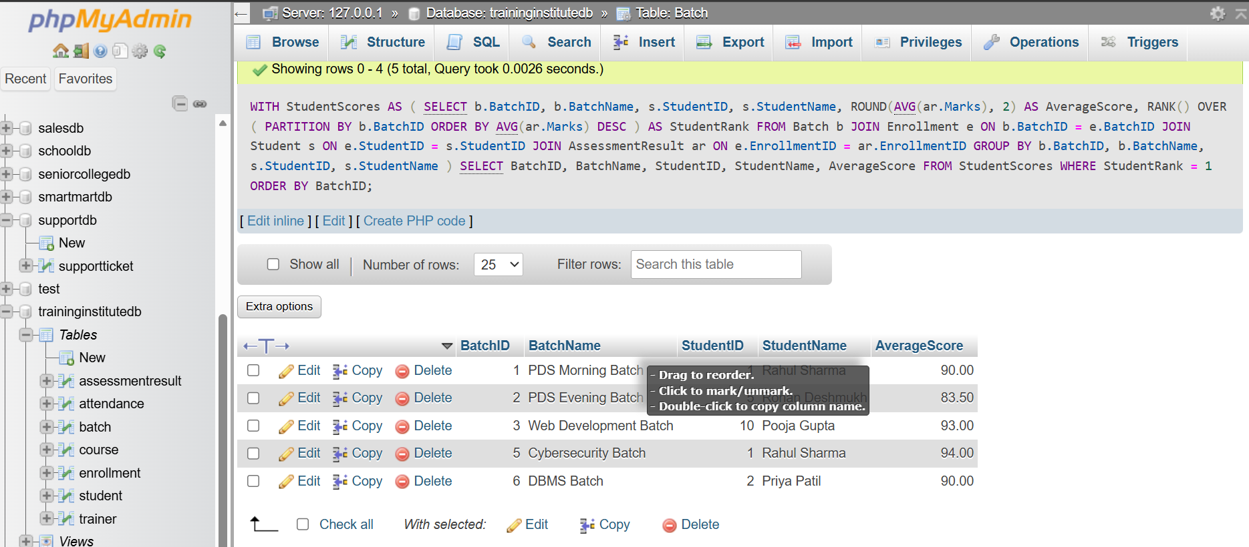

Students Who Have Not Attended Any Session
QUERY
SELECT
s.StudentID,
s.StudentName
FROM Student s
LEFT JOIN Enrollment e
ON s.StudentID = e.StudentID
LEFT JOIN Attendance a
ON e.EnrollmentID = a.EnrollmentID
WHERE a.AttendanceID IS NULL
ORDER BY s.StudentID;
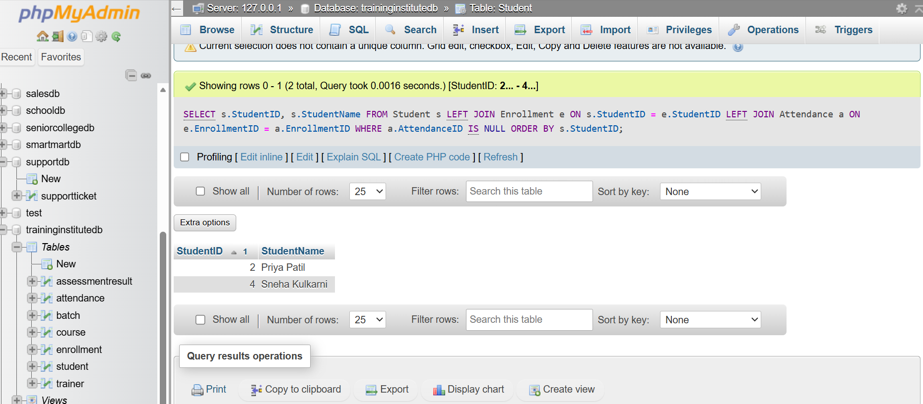

Course-wise Performance Analysis
QUERY
SELECT
c.CourseID,
c.CourseName,
ROUND(AVG(ar.Marks), 2) AS AverageScore,
COUNT(DISTINCT e.StudentID) AS TotalStudents
FROM Course c
JOIN Batch b
ON c.CourseID = b.CourseID
JOIN Enrollment e
ON b.BatchID = e.BatchID
JOIN AssessmentResult ar
ON e.EnrollmentID = ar.EnrollmentID
GROUP BY
c.CourseID,
c.CourseName
ORDER BY AverageScore DESC;
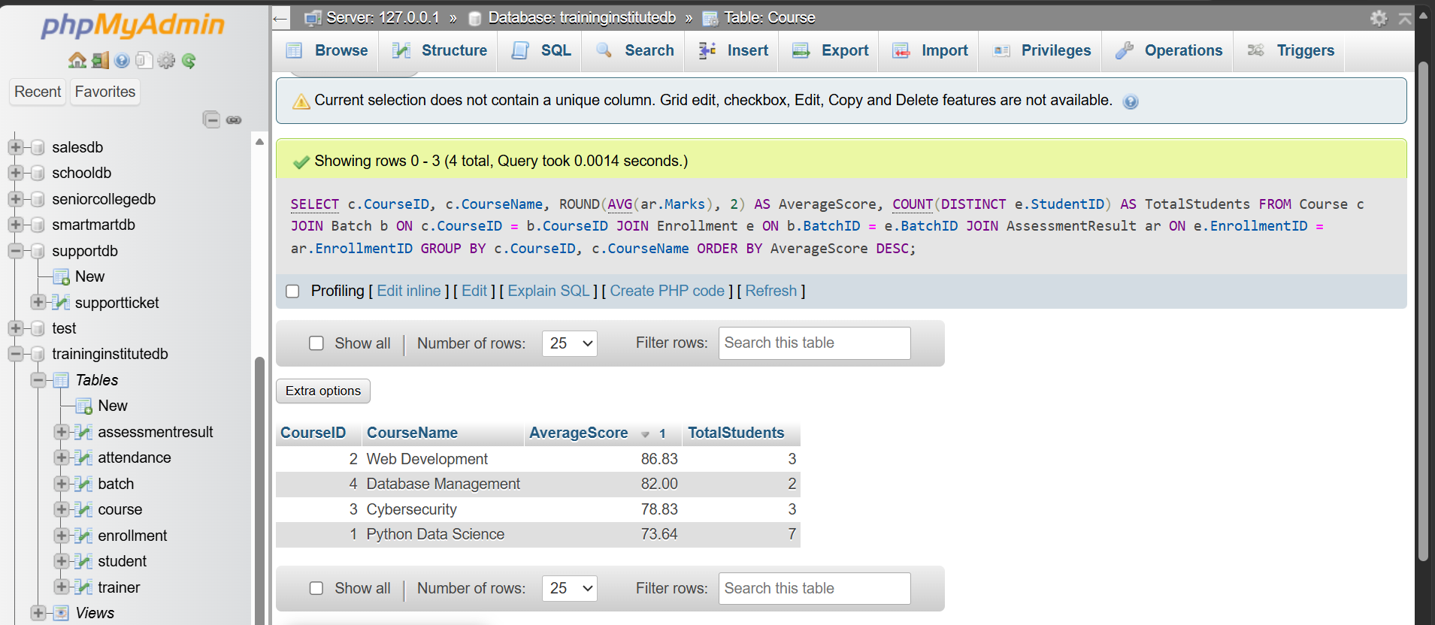

Overall Student Ranking
QUERY
SELECT
s.StudentID,
s.StudentName,
ROUND(AVG(ar.Marks), 2) AS AverageScore,
RANK() OVER (
ORDER BY AVG(ar.Marks) DESC
) AS StudentRank
FROM Student s
JOIN Enrollment e
ON s.StudentID = e.StudentID
JOIN AssessmentResult ar
ON e.EnrollmentID = ar.EnrollmentID
GROUP BY
s.StudentID,
s.StudentName
ORDER BY StudentRank;

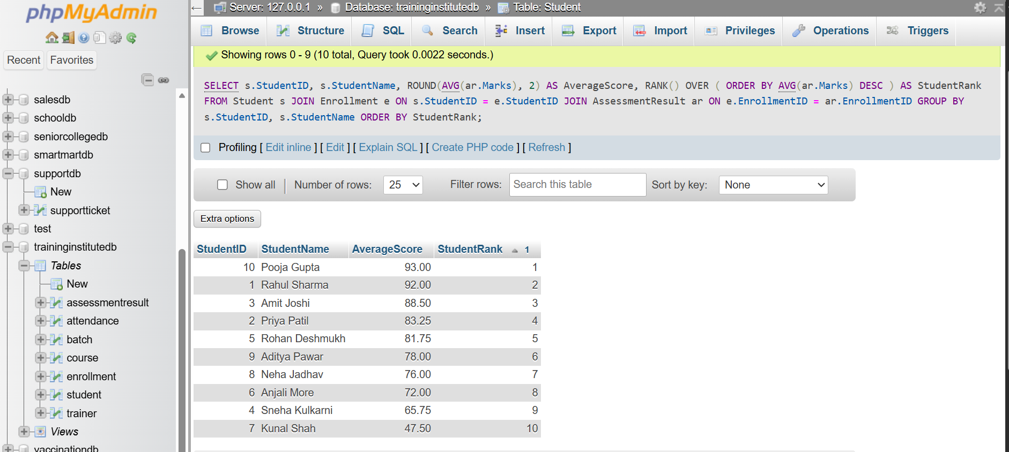

Average Attendance by Batch
QUERY

SELECT
b.BatchID,
b.BatchName,
ROUND(
AVG(
CASE
WHEN a.Status = 'Present' THEN 100
ELSE 0
END
),
2
) AS AverageAttendance
FROM Batch b
JOIN Enrollment e
ON b.BatchID = e.BatchID
JOIN Attendance a
ON e.EnrollmentID = a.EnrollmentID
GROUP BY
b.BatchID,
b.BatchName
ORDER BY AverageAttendance DESC;
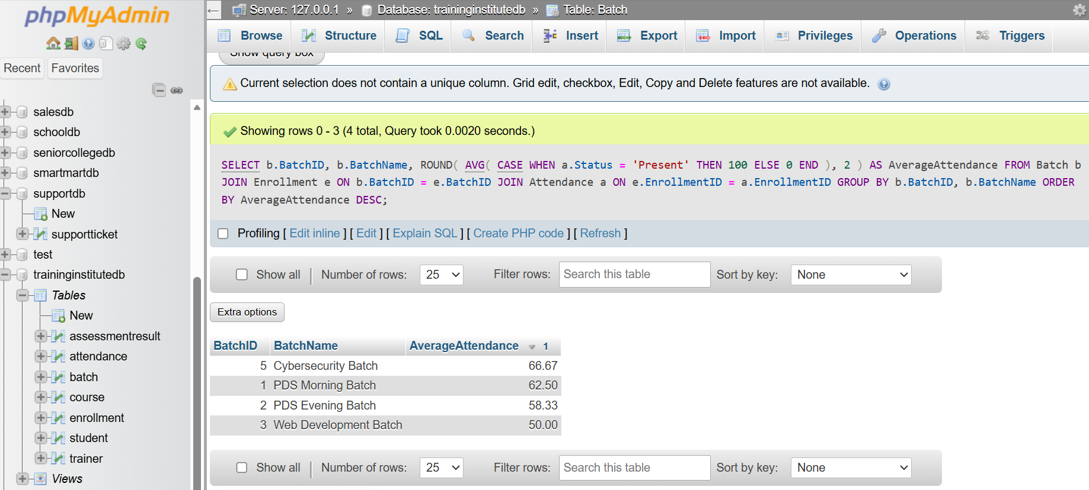

Student-wise Training Progress
QUERY
SELECT
s.StudentID,
s.StudentName,
b.BatchName,
c.CourseName,
ROUND(AVG(ar.Marks), 2) AS AverageScore
FROM Student s
JOIN Enrollment e
ON s.StudentID = e.StudentID
JOIN Batch b
ON e.BatchID = b.BatchID
JOIN Course c
ON b.CourseID = c.CourseID
LEFT JOIN AssessmentResult ar
ON e.EnrollmentID = ar.EnrollmentID
GROUP BY
s.StudentID,
s.StudentName,
b.BatchID,
b.BatchName,
c.CourseID,
c.CourseName
ORDER BY
s.StudentID,
b.BatchID;

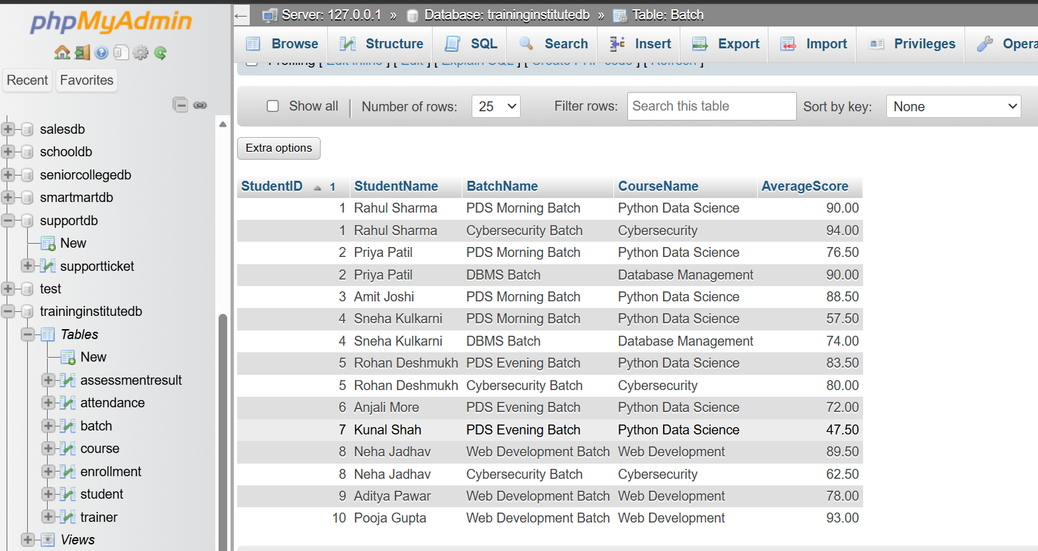

Students Performing Above Overall Average
QUERY
SELECT
s.StudentName,
ROUND(AVG(ar.Marks), 2) AS AverageScore
FROM Student s
JOIN Enrollment e
ON s.StudentID = e.StudentID
JOIN AssessmentResult ar
ON e.EnrollmentID = ar.EnrollmentID
GROUP BY
s.StudentID,
s.StudentName
HAVING AVG(ar.Marks) > (
SELECT AVG(Marks)
FROM AssessmentResult
)
ORDER BY AverageScore DESC;
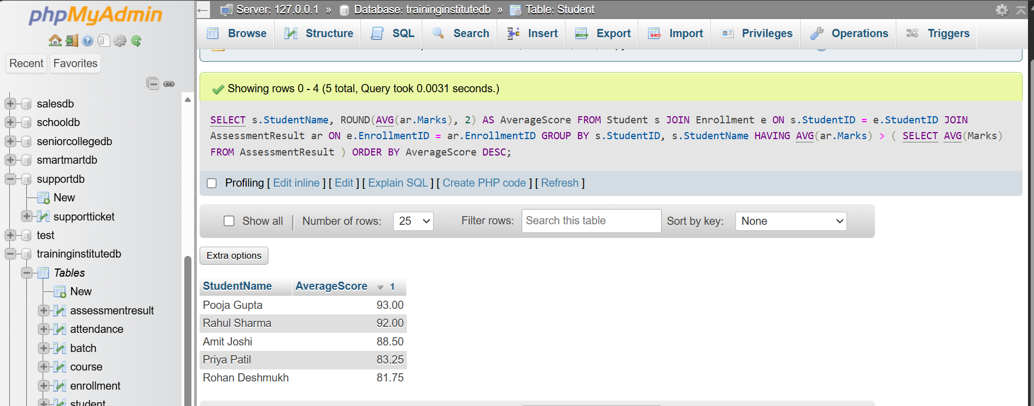

Highest Marks Obtained in Each Course
QUERY
SELECT
c.CourseName,
MAX(ar.Marks) AS HighestMarks
FROM Course c
JOIN Batch b
ON c.CourseID = b.CourseID
JOIN Enrollment e
ON b.BatchID = e.BatchID
JOIN AssessmentResult ar
ON e.EnrollmentID = ar.EnrollmentID
GROUP BY
c.CourseID,
c.CourseName
ORDER BY HighestMarks DESC;
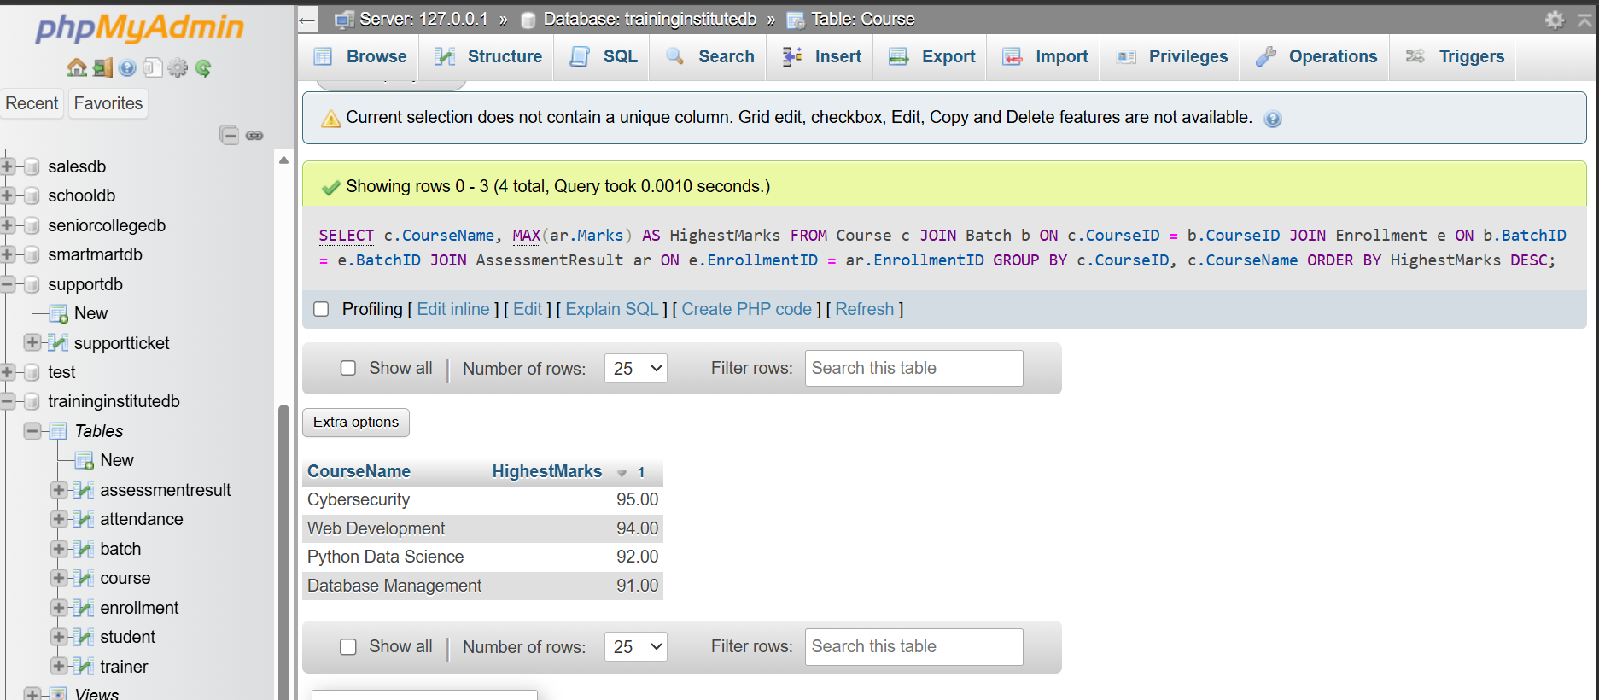

Trainers Handling Multiple Batches
QUERY
SELECT
t.TrainerID,
t.TrainerName,
t.Specialization,
COUNT(b.BatchID) AS TotalBatches
FROM Trainer t
JOIN Batch b
ON t.TrainerID = b.TrainerID
GROUP BY
t.TrainerID,
t.TrainerName,
t.Specialization
HAVING COUNT(b.BatchID) > 1
ORDER BY TotalBatches DESC;
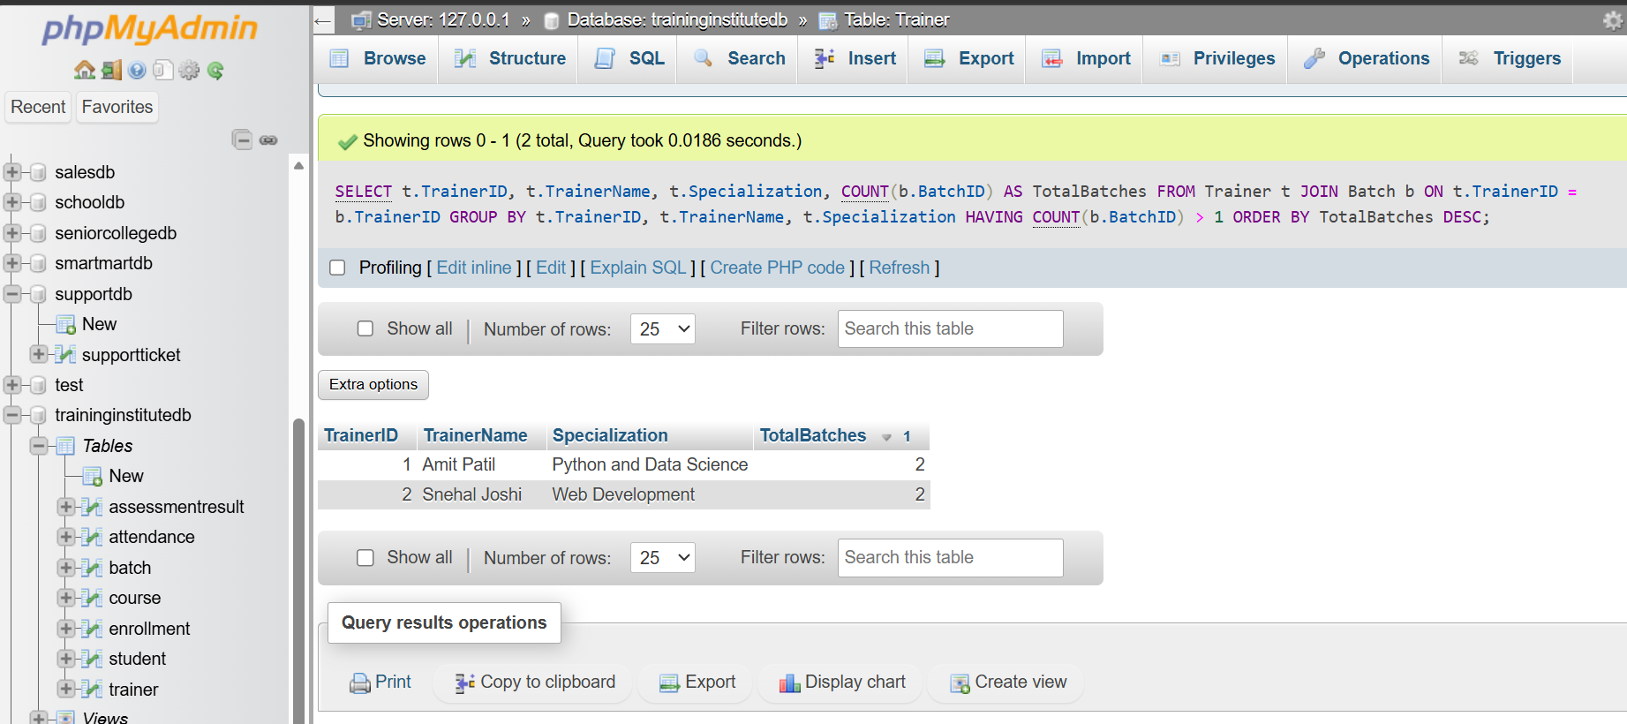

Students Enrolled in More Than One Batch
QUERY
SELECT
s.StudentID,
s.StudentName,
COUNT(e.BatchID) AS TotalBatches
FROM Student s
JOIN Enrollment e
ON s.StudentID = e.StudentID
GROUP BY
s.StudentID,
s.StudentName
HAVING COUNT(e.BatchID) > 1
ORDER BY TotalBatches DESC;
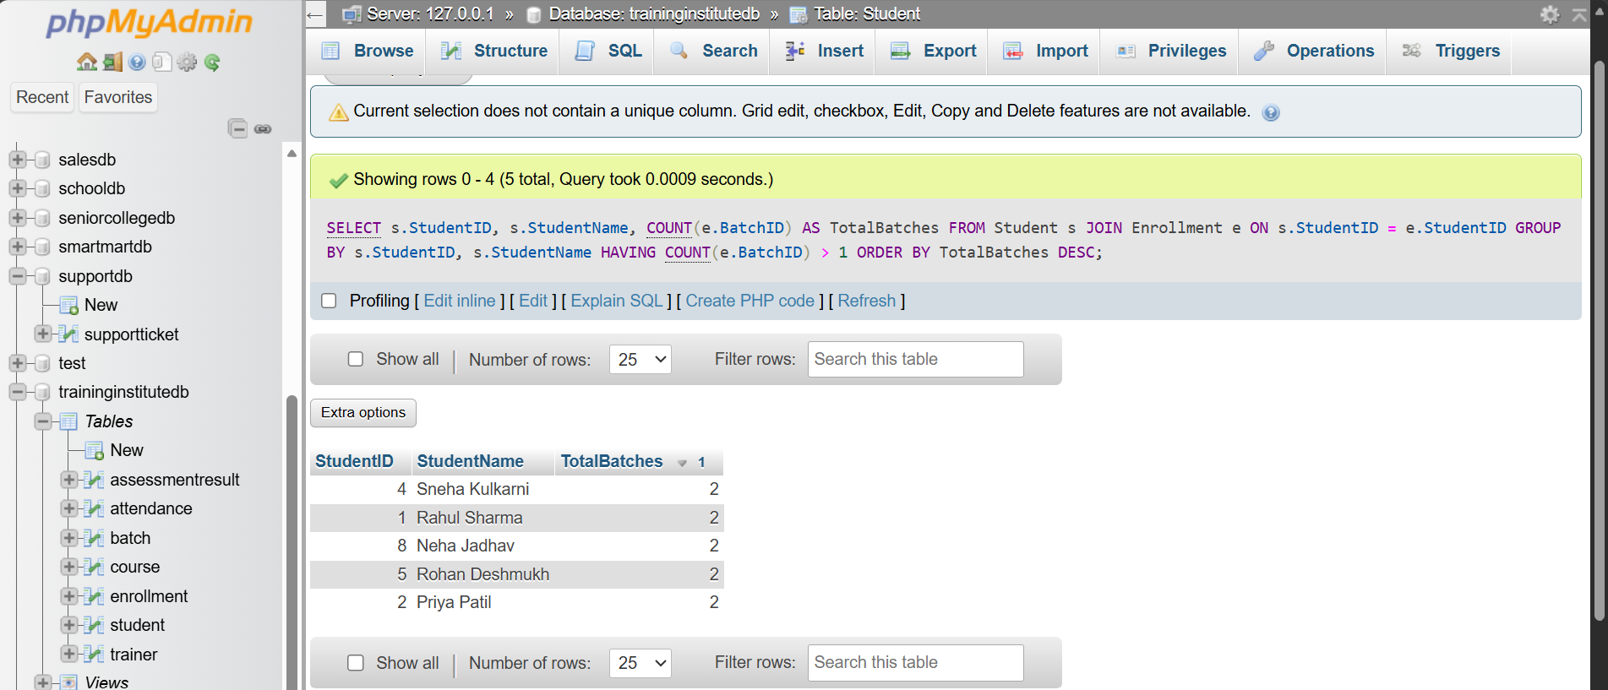

Create StudentProgress View
QUERY
CREATE OR REPLACE VIEW StudentProgress AS
SELECT
s.StudentID,
s.StudentName,
b.BatchName,
c.CourseName,
ROUND(AVG(ar.Marks), 2) AS AverageScore
FROM Student s
JOIN Enrollment e
ON s.StudentID = e.StudentID
JOIN Batch b
ON e.BatchID = b.BatchID
JOIN Course c
ON b.CourseID = c.CourseID
LEFT JOIN AssessmentResult ar
ON e.EnrollmentID = ar.EnrollmentID
GROUP BY
s.StudentID,
s.StudentName,
b.BatchID,
b.BatchName,
c.CourseID,
c.CourseName;
